Professional Learning Resource
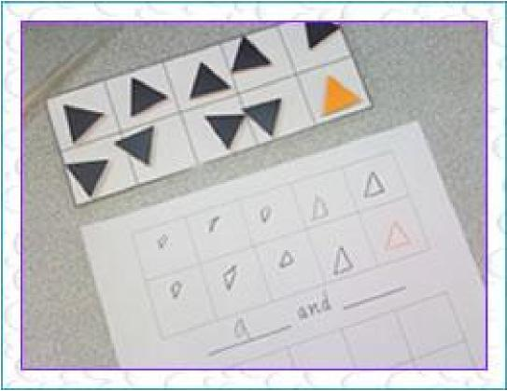 | Make Ten learning activity  In this activity students are given ten double sided tiles and a tens frame.  They shake the tiles in their hands then “splat them down.”  The students then record the different combinations that make ten.  This answer shows 9 and 1 makes ten.  How many different combinations can you find that make ten? Why do students need to learn number facts to 20?

This photo is an example of a task given to Year 1 students. Make ten. In the early years it is important for students to develop part whole understanding of a collection of ten. They need to be able tell us everything there is to know about a number. For example, ten is... five and five, eight and two or three and seven and so on.
Early Years Learning in Mathematics community

Teachers should comprehend what students need to understand before and after this task. As part of the community other educators can make suggestions to similar tasks, pre-tasks and tasks that will scaffold students' understanding once they have developed this concept.
Especially, in the early years, mathematical tasks need to be hands on, often designed to develop understanding of the same concept. Effective teachers often repeat an activity in a similar way with different materials.

As other educators share ideas in this conversation or with other ideas, a specialised language teachers use to support numeracy with young children will also assist their’ pedagogical content knowledge.
This community can support the sharing of these ideas through conversations, sharing of ideas, resources, photos and descriptions of numeracy tasks.

Community shared resource – Sharyn Livy, Early Years Mathematics Specialist

